Exam 2 Basic lecture outline
Check page breaks before printing

V. Chromosomes
A. Structure
1. DNA
a. component molecules
1)
2)
3)
a)
b)
b. ladderlike arrangement
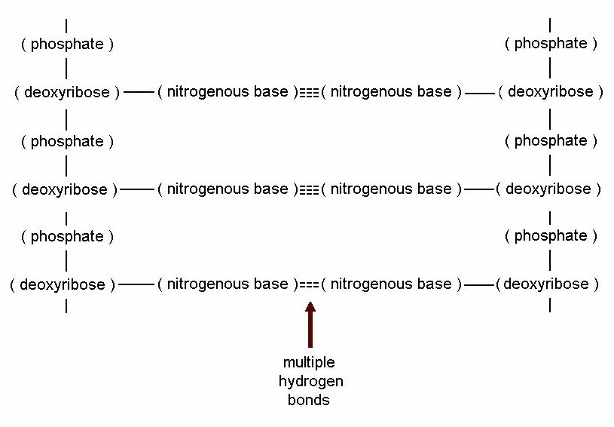

c. double helix
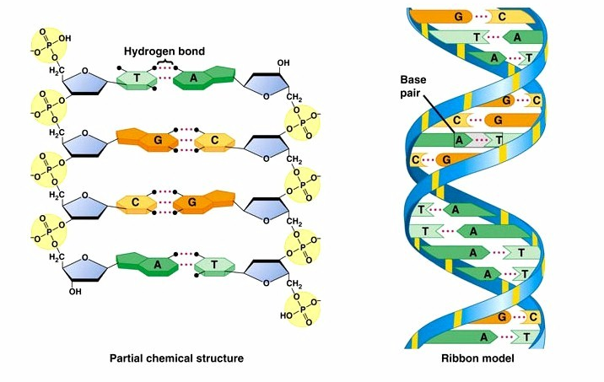

2. a chromosome is
3. efficient storage
a. average human chromosome has 900 genes
b. one human cell
c. one adult human

B. Protein synthesis: how nucleus controls cell
1. transcription
a.
b. DNA is used as a model to make RNA
1)
2)
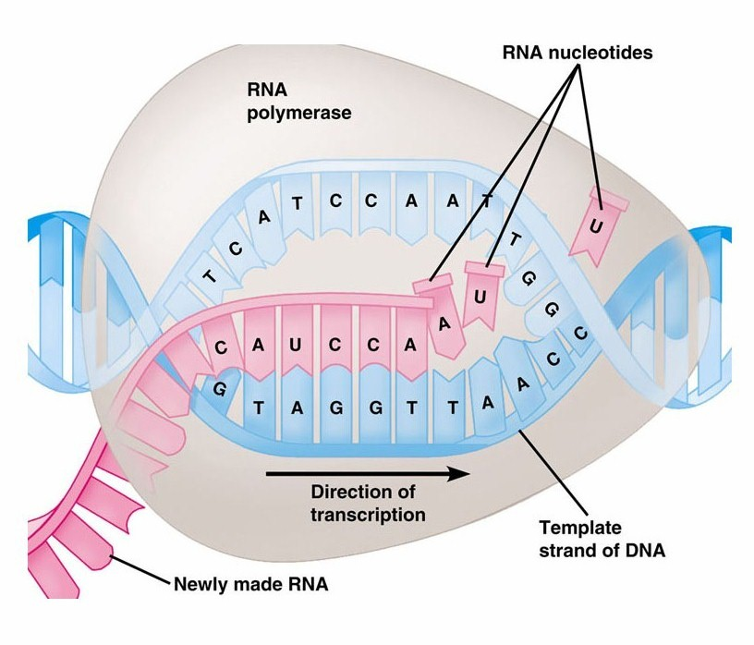

3)
d.
e.
1)
2)
f. new molecule is mRNA: uses ribose and uracil (not thymine)
2. mRNA trimming
a.
b.
c.
d.
3. translation
a.
b.
c. ribosome
1) a set of 3 mRNA nitrogenous bases
2) the complementary tRNA
3) the amino acid is
4)
5) the ribosome moves
6)
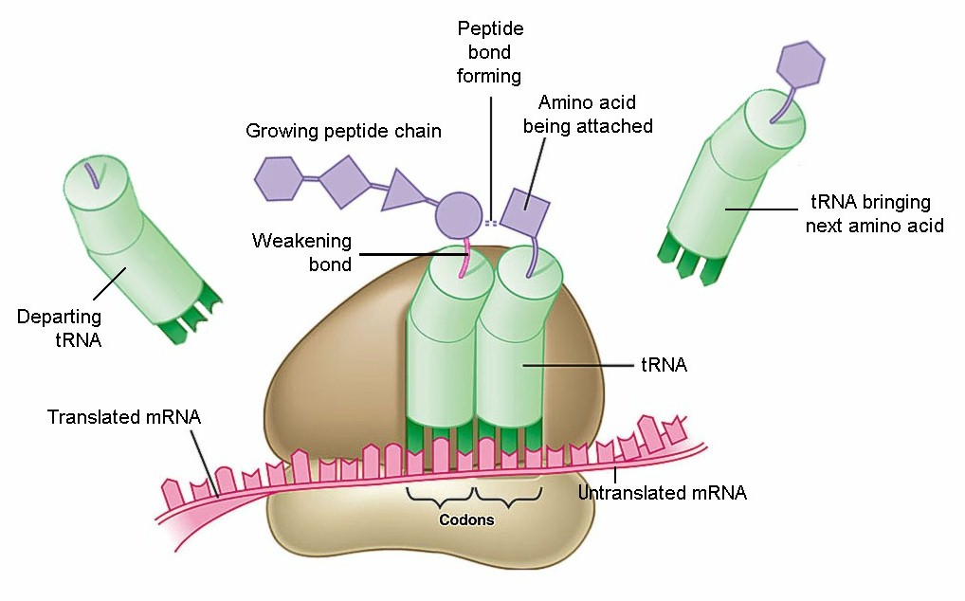

e. mRNA sequence is read in groups of 3
1) it’s a triplet code
2)
3)
f. results
1) specific chain of aa's:
2) DNA, mRNA specify

3) the chain automatically
4) one gene is
Reminder: “Your Genome” video on YouTube & Canvas
4. errors:
a. sources
1)
a)
b)
c)
2)
a)
b) only in that one cell
c)
b. effect varies
1) final protein may be OK
2) final protein may
3) final protein may
c. types of errors
1)
a) the wrong
b) example
normal AGU GUC CCA TCG UGC CAA
substituted AGU GAC CCA TCG UGC CAA

c) generally, least serious error
d) one serious example
(1) in DNA, one base out of 438 bases is wrong
(2) causing the 6th amino acid to be different
(3) the protien becomes sticky without oxygen
(5) causes the cell to become arc-shaped
(6) can be fatal: sickle cell anemia
2) base-pair inversion
a)
b) example
normal AGU GUC CCA TCG UGC CAA
inverted AGG UUC CCA TCG UGC CAA

c)
3) frame shift mutation
a) new
b) example
normal AGU GUC CCA TCG UGC CAA
inserted AGG UGU CCC ATC GUG CCA A
c) reading frame is shifted: codons are different
d) causes a different sequence of amino acids
e) often very serious,
5. control of gene activity
a.
b.
1)
2)
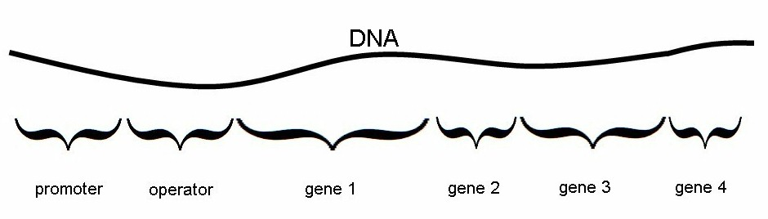

c. example: genes that code for the enzymes of glycolysis
6. proteins control

C. Cell cycle
1. interphase
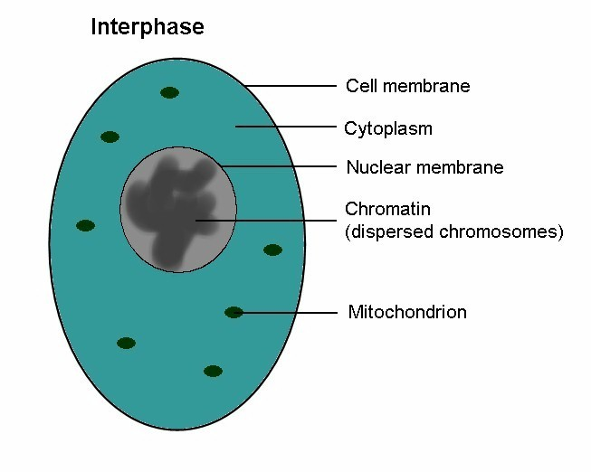
a.
1)
2)
3)
b.
1) two identical copies
2)
3)
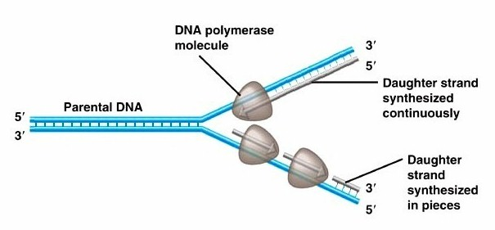

a) each
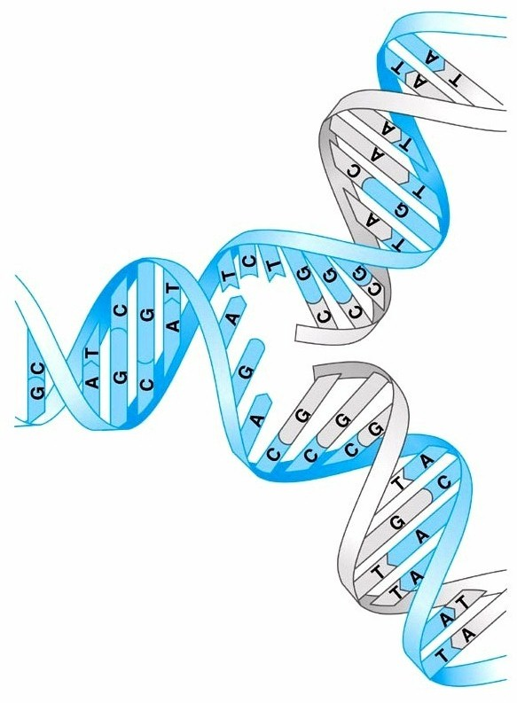

b) strands stay attached
c) the 3rd benefit of double-stranded DNA:
c. G2 Phase (Gap 2):
2. mitosis =
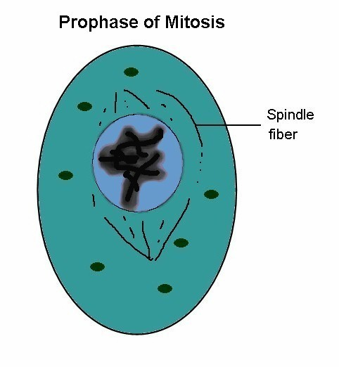
a. prophase
1) nuclear membrane
2) chromosomes
3) spindle
b. metaphase
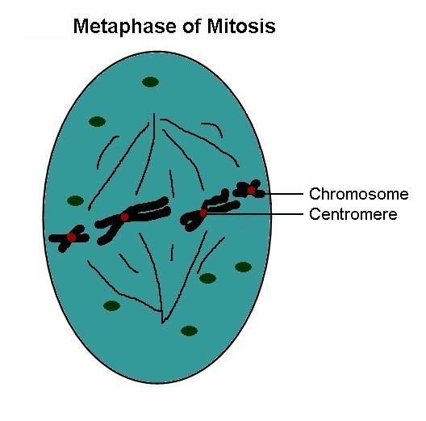
1) chromosomes

c. anaphase
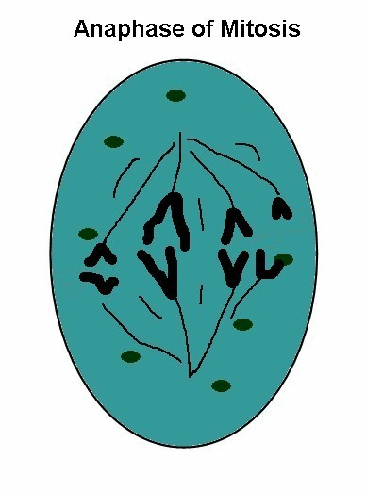
1) centromere
2)

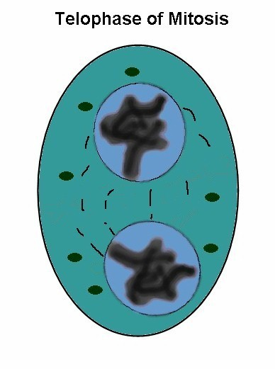
d. telophase
1) chromosomes
2) nuclear membrane

3. cytokinesis = cytoplasm division
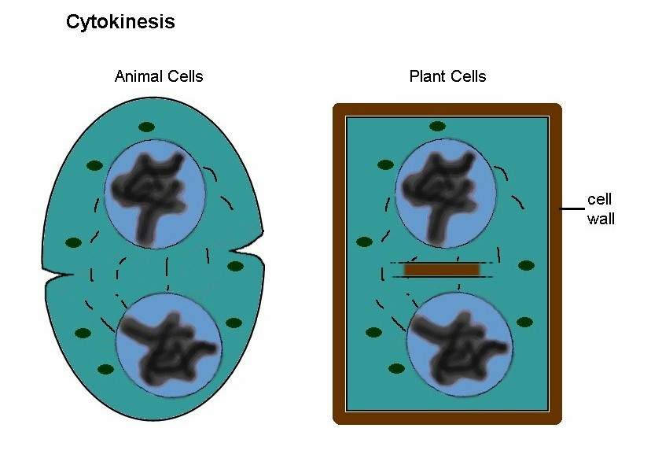
a. usually follows mitosis
b. animals:

c. others:

d. other cell organelles are

Reminder: video on Canvas and at http://vcell.ndsu.nodak.edu/animations/

D. Meiosis
1. produces
2. results in a
a. 2n --> 1n
b. diploid =
c. meiosis in
d. goal:
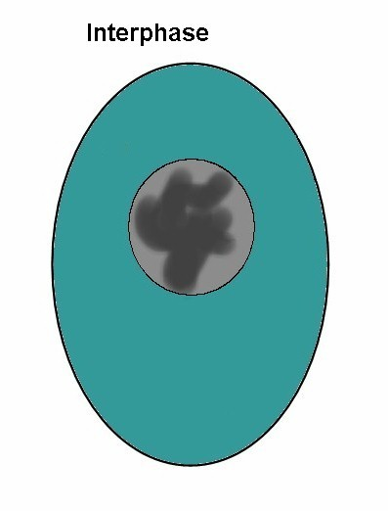
3. process
a. meiosis I: halves chromosome count
1) prophase I
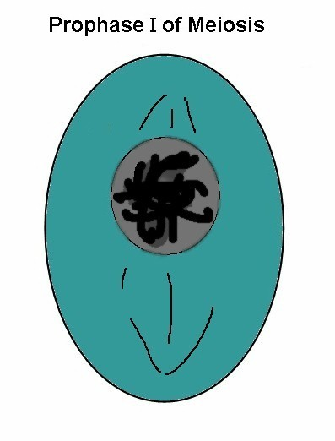
a) nuclear membrane
disintegrates, spindle forms
b) sister chromosomes pair
c) crossover occurs
d) chromosomes condense
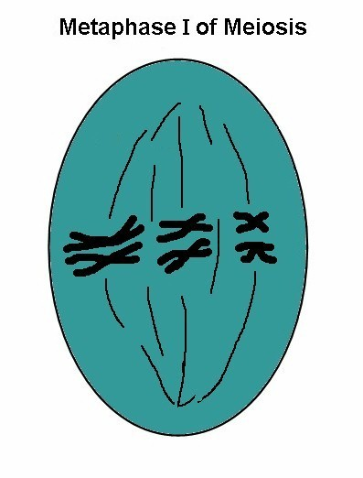
2) metaphase I
a) pairs align at equator
b) independent assortment occurs
(= independent orientation)
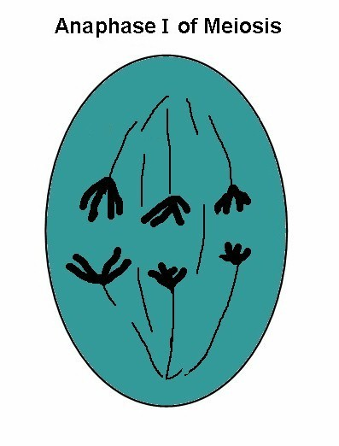
3) anaphase I
a) members

b) no
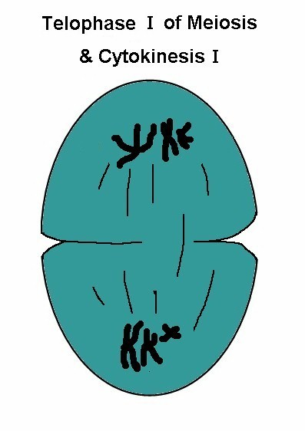
4) telophase I & cytokinesis I:
nucleus doesn't usually reform

b. meiosis II: looks like mitosis
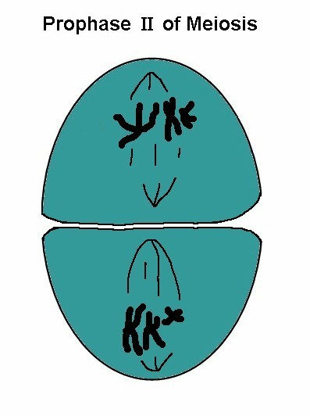
1) prophase II:

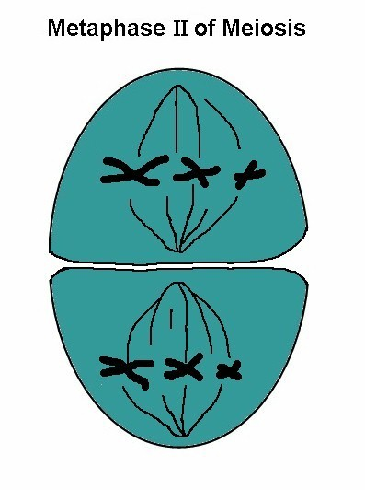
2) metaphase II:

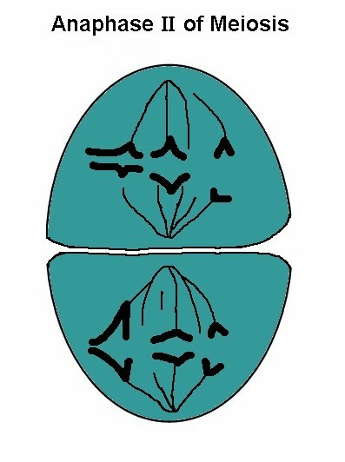
3) anaphase II:

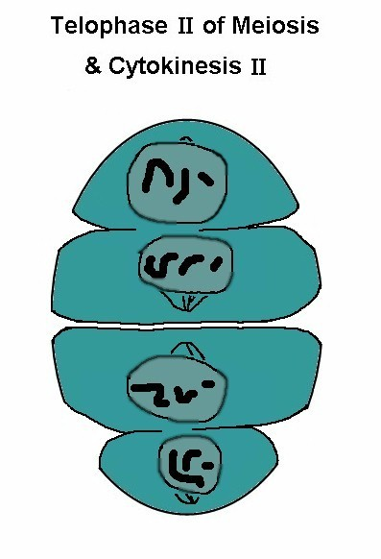
4) telophase II & cytokinesis II:

4. ways of reshuffling DNA
a.
1)
2) members of chromosome pair

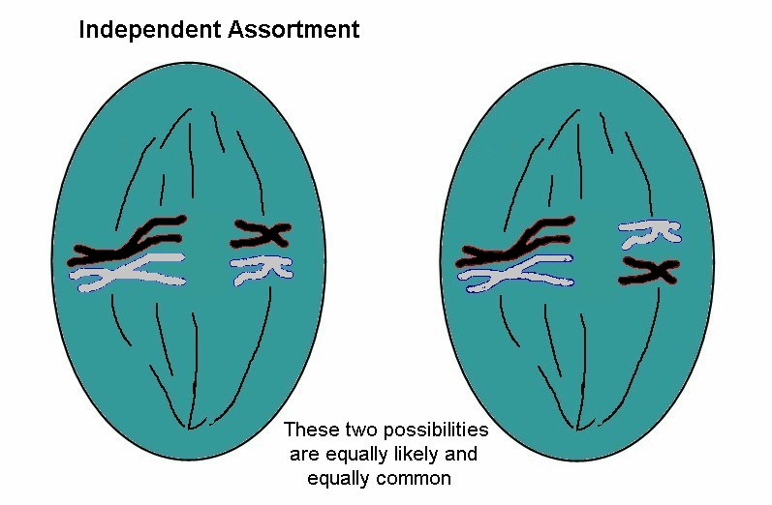

3) two pair chromosomes (2n=4) means 4 different
assortments
4) humans: 2n = 46, n = 23
that’s 2²³ unique combinations =
b. crossover
1) prophase I
2) sister chromosomes
3) sequence:
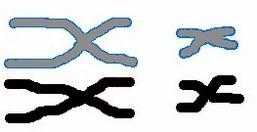
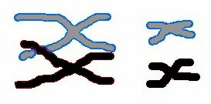
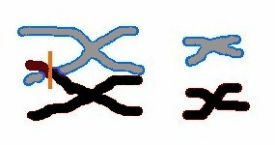
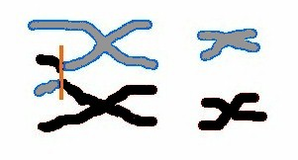
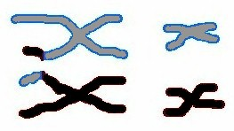

4) usually
5) so even
Hint: Make sure you understand meiosis, especially DNA shufflling
VI. Mendelian Genetics

A. Mendel: 1850s
1. no chromosomes known
2.
3.

B. Terms
1. gene:
2. alleles:
a.
b.
3. dominant allele
a.
b.
c. "dominant gene"
4. recessive allele:

5. co-dominant alleles
a. neither is
b. both
c. e.g. red snapdragons x white snapdragons ----> pink
6. homozygous:
7. heterozygous:
8. genotype:
9. phenotype:
10. linkage:

C. Symbols
1. most organisms are diploid
a. two
b.
2. most genes have three or four alleles; we'll use mostly 2
3. two-allele systems
a. use capital letter for the dominant allele
b. e.g watermelons: short (S) is dominant to long (s)

D. Crosses
1. monohybrid crosses: one trait
a.
P:
P gametes:
F1:
F2:
b. explanation
1)
a)
b) e.g. S and s gametes
2)
a)

b) bring top & side alleles together in the boxes
 | S | S
s | Ss | Ss
s | Ss | Ss

3) predicting the F2:
 | S | s
S
s

Phenotype ratio is 3:1

c. test cross:
1) if F1 has some
2) if F1 is all S_
d. co-dominance:
(example: snapdragons)
P:
F1:
F2:

2. dihybrid unlinked
a. P: SSGG (short, green) x ssgg (long, striped)
 | SG | SG
sg
sg

all short and green in the F1

b. let these self-fertilize: SsGg x SsGg

 | SG | Sg | sG | sg
SG
Sg
sG
sg

F2 ratios of phenotypes:
short green (S_G_)
short striped (S_gg)
long green (ssG_)
long striped (ssgg)
c. independent assortment
1)
2) so their recombination is
3)
3. dihybrid linked:
a. alleles
b. ratio is not 9:3:3:1 in F2
P:
F1:
F2: ??
c. if no crossover, then F2 is…

d. linked with crossover
1) F2 ratios

2)
3)

4. sex linked:
a. 23 pair of chromosomes in male is XY, female is XX
b.
c.
d.

e. example: sex determination (XX x XY)
 | X | Y
X
X

f. e.g. hemophilia
1) on X chromosome
2) new type of symbols
a) X^{H} for dominant allele
b) X^{h} for recessive allele
c) Y as a place holder in males
3) examples
a) male X^{h}Y x female X^{H}X^{H} -->

b) female carrier X^{H}X^{h} x male normal X^{H}Y -->

c) female carrier X^{H}X^{h} x afflicted male X^{h}Y --->

5. summary of ratios
Cross | Ratios | Percentages
Monohybrid
simple dominance
Monohybrid
codominance
Dihybrid
unlinked
Dihybrid linked
no crossover
Dibhybrid linked  with crossover | varies | 56-75 : 0-19 : 0-19 : 6-25

6. monohybrid, three alleles
a. example: ABO blood proteins
1) complex situation with 3 alleles of one gene
a)
b)
2) phenotypes
Type A blood: possible genotypes are ??
Type B blood: possible genotypes are ??
Type O blood: possible genotypes are ??
Type AB blood: possible genotypes are ??
3) sample crosses
AB x OO AO x BO AB x AB

4) proportions in the human population
a) Type A:
b) Type B:
c) Type O:
d) Type AB:
7. genetics problems (handout)
8. controversy: recombinant DNA (genetic modification)
a. transplants beneficial genes
b. allows quick improvement of crops, livestock:
1) improved
2) nutritional improvement:
3) pharming: grow organisms with added genes that
make medicines (e.g. insulin) -- “biologics” like
Humira, Enbrel ($70 billion/year for top ten alone)
c. concerns
1) ethics:
2) modified animals are
3) lateral gene transfer: modified genes might “escape”
from a crop to a wild population;

